Warehouse Inventory Application

Rushilkumar Patel

Sapanaben Makadia

Keyur Lakhani

Fairleigh Dickinson University, Teaneck, NJ 07601

**Use Case**

***Use case Name***: InsertProduct

***Participating Actors:*** Manager

***Flow of an Event:***

* Manager receives products in the warehouse.
* Manager opens WIA and pick up the store location.
* Manager Login in the WIA using his Login ID and Password.
* Manager click inset options to add an items in the inventory.
* He scans the SKU (Stock Keeping Unit) of the product.
* He scans the serial number of the products.
* He posts the scanned serial number into the WIA, so Products are being added in the WIA.
* He Logged out from the WIA.

**Entry Condition**:

* Manager can open WIA and Login in the system.

**Exit Condition**:

* Received scanned Products should be added in the WIA.

**Quality Requirement**:

* Manager able to add multiple of items in the WIA at a time.

***Use case Name***: DeleteProduct

***Participating Actors:*** Manager

***Flow of an Event:***

* Manager receives products in the warehouse.
* Manager opens WIA and pick up the store location.
* Manager Login in the WIA using his Login ID and Password.
* Manager click Delete options to add an items in the inventory.
* He scans the SKU of the product.
* He scanned the serial number of the product.
* He posts the scanned serial number into the WIA, so Products are being deleted in the WIA.

**Entry Condition**:

* Manager can open WIA and Login in the system.

**Exit Condition**:

* Scanned Products should be deleted in the WIA.

**Quality Requirement**:

* Manager able to delete multiple of items in the WIA at a time.

***Use case Name***: ThresholdLevel

***Participating Actors:*** Manager

***Flow of an Event:***

* Manager opens WIA and pick up the store location.
* Manager Login in the WIA using his Login ID and Password.
* Manager clicks Maintain Threshold in the WIA.
* Manager scans SKU or search the product using product id, product name, serial number, vender name and pick up the product.
* Manager sets Minimum and Maximum quantity of the product.
* Manager can also set notification method, from email or text or both.
* He Logged out from the WIA.

**Entry Condition**:

* Manager can open WIA and Login in the system.

**Exit Condition**:

* Manager can able to set minimum and maximum quantity of each product.

**Quality Requirement**:

* Manager able to notified by selected method of notification if quantity is above or below the threshold level.

***Use case Name***: TransferProduct

***Participating Actors:*** Sender Manager, Receiver Manager

***Flow of an Event:***

* Sender Manager opens WIA and pick up the store location.
* Sender Manager Login in the WIA using his Login ID and Password.
* Sender Manager Clicks Transfer in WIA.
* Sender Manager makes transfer request to selected store with SKU of the products having serial numbers.
* Another store receiver manager login in the system and accept it if their warehouse location needs that product or decline the request.
* Receiver Manager opens WIA and pick up the store location.
* Receiver Manager Login in the WIA using his Login ID and Password.
* Receiver Manager accept the transfer request.
* Receiver Manager scanned the received items with SKU of the product and scan the serial number of product.
* Receiver Manager acknowledged the transfer to the sender Manager.
* Receiver Manager Logged out from the WIA.

**Entry Condition**:

* Manager can open WIA and Login in the system.

**Exit Condition**:

* Manager is able to transfer the product from one location to another location.

**Quality Requirement**:

***Use case Name***: ReplacementProduct

***Participating Actors:*** Manager

***Flow of an Event:***

* Manager opens WIA and pick up the store location.
* Manager Login in the WIA using his Login ID and Password.
* Manager click replacement.
* Manager scan the SKU and serial number of the product.
* Manager jot down the issue related to the replacement.
* WIA automatically generate a return form to the vendor and ask manager to submit return form to the vendor or not?
* If yes, then report has been sent to the vendor or request can be saved in the WIA.
* Manager logged out from the WIA.

**Entry Condition**:

* Manager can open WIA and Login in the system.

**Exit Condition**:

* WIA is able to generate return form and ask manager to submit it? If submitted, form has been sent to the vendor.

**Quality Requirement**:

* Vendor receives replacement form.

***Use case Name***: Search

***Participating Actors:*** Manager

***Flow of an Event:***

* Manager opens WIA and pick up the store location.
* Manager Login in the WIA using his Login ID and Password.
* Manager click search.
* Manager scan the SKU and serial number of the product.
* Manager can type vendor name, color, size, configuration and specification of the product.
* Manager logged out from the WIA.

**Entry Condition**:

* Manager can open WIA and Login in the system.

**Exit Condition**:

* Manager able to search the product.

**Quality Requirement**:

* Manager able to search the product by SKU, product ID, product name, specification, size, type and configuration.

***Use case Name***: Order

***Participating Actors:*** Manager

***Flow of an Event:***

* Manager opens WIA and pick up the store location.
* Manager Login in the WIA using his Login ID and Password.
* Manager click order.
* Manager select product to be ordered by using SKU, product Id, Vendor Id or serial number.
* Manager can enter the quantity.
* Manager submit it.
* WIA create a form to order.
* Manager receives an acknowledge when vendor receives an order.
* Manager logged out from the WIA.

**Entry Condition**:

* Manager can open WIA and Login in the system.

**Exit Condition**:

* Manager can order product.

**Quality Requirement**:

* Manager receives an acknowledgement when vendor receives an order.

**Scenario**

***Use case Name***: InsertProduct

***Participating Actors:*** Manager:Ryan

***Flow of an Event:***

* Ryan receives products in the warehouse.
* Ryan opens WIA and pick up the store location.
* Ryan Login in the WIA using his Login ID and Password.
* Ryan click inset options to add an items in the inventory.
* He scans the SKU (Stock Keeping Unit) of the product.
* He scans the serial number of the products.
* He posts the scanned serial number into the WIA, so Products are being added in the WIA.
* He Logged out from the WIA.

***Use case Name***: DeleteProduct

***Participating Actors:*** Manager:Ryan

***Flow of an Event:***

* Ryan receives products in the warehouse.
* Ryan opens WIA and pick up the store location.
* Ryan Login in the WIA using his Login ID and Password.
* Ryan click Delete options to add an items in the inventory.
* He scans the SKU of the product.
* He scanned the serial number of the product.
* He posts the scanned serial number into the WIA, so Products are being deleted in the WIA.

***Use case Name***: ThresholdLevel

***Participating Actors:*** Manager:Ryan

***Flow of an Event:***

* Ryan opens WIA and pick up the store location.
* Ryan Login in the WIA using his Login ID and Password.
* Ryan clicks Maintain Threshold in the WIA.
* Ryan scans SKU or search the product using product id, product name, serial number, vender name and pick up the product.
* Ryan sets Minimum and Maximum quantity of the product.
* Ryan can also set notification method, from email or text or both.
* He Logged out from the WIA.

***Use case Name***: TransferProduct

***Participating Actors:*** Sender Manager:Ryan , Receiver Manager:Gemi

***Flow of an Event:***

* Ryan opens WIA and pick up the store location.
* Ryan Login in the WIA using his Login ID and Password.
* Ryan Clicks Transfer in WIA.
* Ryan makes transfer request to selected store with SKU of the products having serial numbers.
* Another store receiver manager login in the system and accept it if their warehouse location needs that product or decline the request.
* Gemi opens WIA and pick up the store location.
* Gemi Login in the WIA using his Login ID and Password.
* Gemi accept the transfer request.
* Gemi scanned the received items with SKU of the product and scan the serial number of product.
* Gemi acknowledged the transfer to the Ryan.
* Gemi Logged out from the WIA.

***Use case Name***: ReplacementProduct

***Participating Actors:*** Manager:Ryan

***Flow of an Event:***

* Ryan opens WIA and pick up the store location.
* Ryan Login in the WIA using his Login ID and Password.
* Ryan click replacement.
* Ryan scan the SKU and serial number of the product.
* Ryan jot down the issue related to the replacement.
* WIA automatically generate a return form to the vendor and ask Ryan to submit return form to the vendor or not?
* If yes, then report has been sent to the vendor or request can be saved in the WIA.
* Ryan logged out from the WIA.

***Use case Name***: Search

***Participating Actors:*** Manager:Ryan

***Flow of an Event:***

* Ryan opens WIA and pick up the store location.
* Ryan Login in the WIA using his Login ID and Password.
* Ryan click search.
* Ryan scan the SKU and serial number of the product.
* Ryan can type vendor name, color, size, configuration and specification of the product.
* Ryan logged out from the WIA.

***Use case Name***: Order

***Participating Actors:*** Manager:Ryan

***Flow of an Event:***

* Ryan opens WIA and pick up the store location.
* Ryan Login in the WIA using his Login ID and Password.
* Ryan click order.
* Ryan select product to be ordered by using SKU, product Id, Vendor Id or serial number.
* Ryan can enter the quantity.
* Ryan submit it.
* WIA create a form to order.
* Ryan receives an acknowledge when vendor receives an order.
* Ryan logged out from the WIA.

***Use case Diagram***

* **Insert / Delete Use Case:**

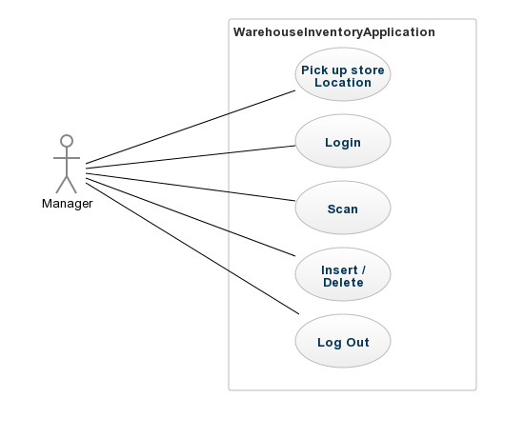

* **Order:**

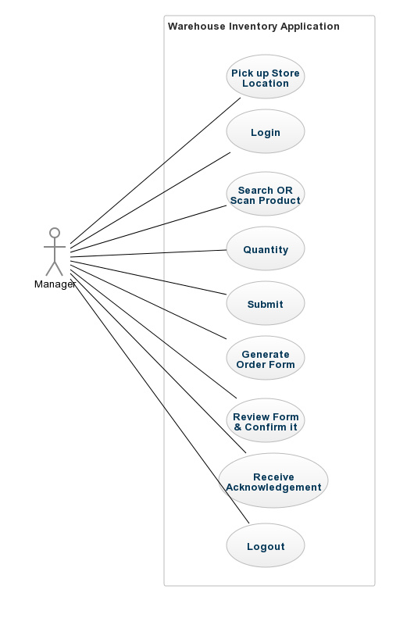

* **Replacement:**

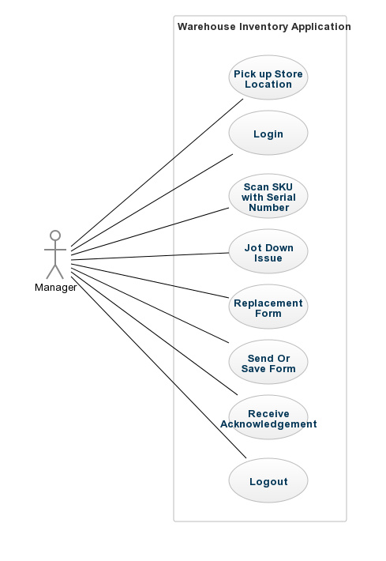

* **Search:**

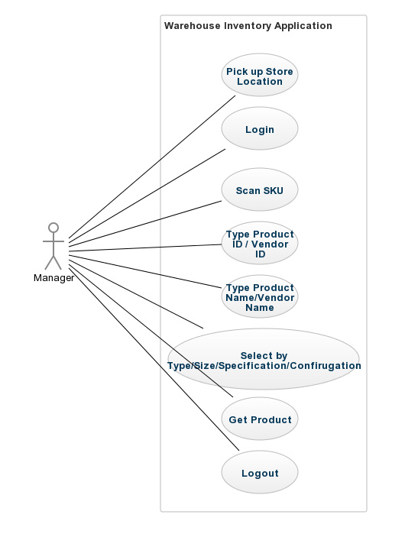

* **Threshold:**

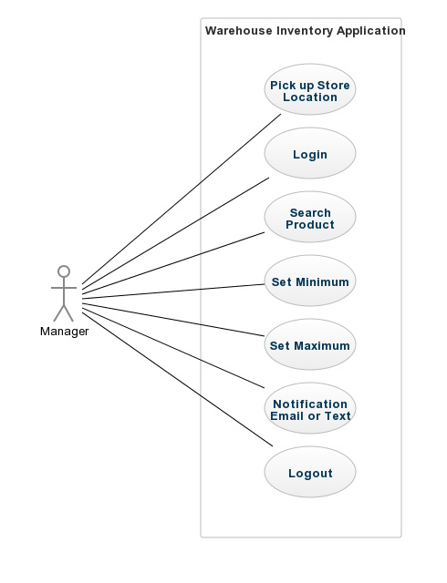

* **Transfer:**

